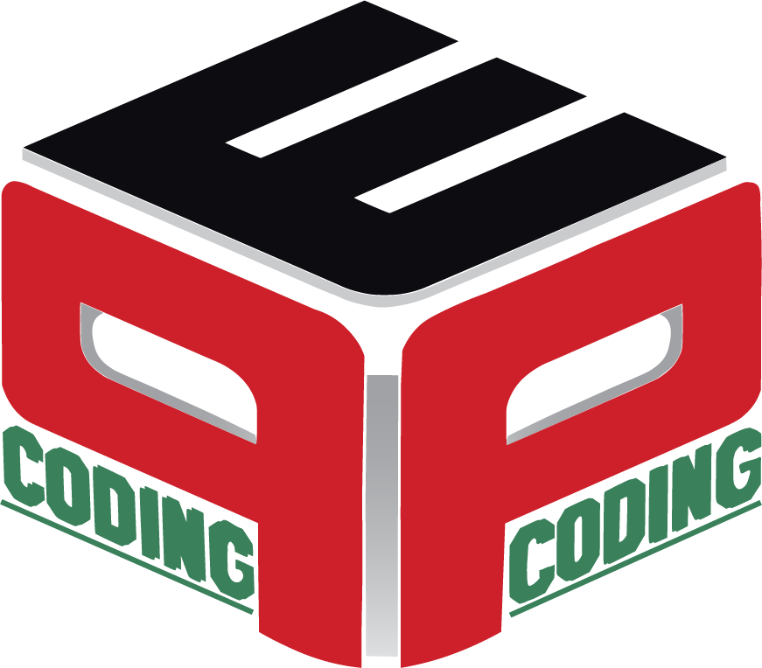

Data modelling is critical for any data-driven organisation because it holds the needs and requirements of the business up against the organisation’s data and optimises the data for business use.

Data modelling applies the needs and requirements of a business to the design of a data storage system. Organisations that collect and use a high volume of data will find that data modelling ensures a higher quality of data. Data modelling provides a standards-based methodology for designing, managing and growing data assets.

Some Terms and Terminologies.

1. Entity
   1. Entity Types
   2. Entity Sets
2. Attribute
   1. Simple or Atomic v/s Composite
   2. Single Valued v/s Multi Valued
   3. Stored v/s Derived
   4. Null Values
   5. Complex Attributes
   6. Key Attribute
3. Relationship
   1. Degree
      1. Binary
      2. Ternary
      3. N-ary
   2. Cardinality Ratio
   3. Participation or Minimum Cardinality Constraint
      1. Total or Existence Dependency
      2. Partial
   4. Attributes
4. Weak Entity Types

Let’s create a sample database application, called COMPANY, which serves to illustrate the basic ER model concepts and their use in schema design. We list the data requirements for the database here, and then create its conceptual schema step-by-step as we introduce the modelling concepts of the ER model.

The COMPANY database keeps track of a company’s employees, departments, and projects. Suppose that after the requirements collection and analysis phase, the database designers provide the following description of the miniworld—the part of the company that will be represented in the database.

1. The company is organised into departments. Each department has a unique name, a unique number, and a particular employee who manages the department and it must have a manager at all times. We keep track of the start date when that employee began managing the department. A department may have several locations.
2. A department controls a number of projects, each of which has a unique name, a unique number, and a single location. Some departments may control no projects.
3. The database will store each employee’s name, Social Security number, address, salary, sex (gender), and birth date. An employee is assigned to one department, but may work on several projects and a project can have several employees working on it, which are not necessarily controlled by the same department. It is required to keep track of the current number of hours per week that an employee works on each project, as well as the direct supervisor of each employee (who is another employee).Not every employee is a supervisor and not every employee has a supervisor.
4. The database will keep track of the dependents of each employee for insurance purposes, including each dependent’s first name, sex, birth date, and relationship to the employee.

Consider a mail order database in which employees take orders for parts from

customers. The data requirements are summarised as follows:

1. The mail order company has employees identified by a unique employee number, their first and last names, and a zip code where they are located.
2. The customers of the company are identified by a unique customer number, their first and last names, and a zip code where they are located.
3. The parts being sold by the company are identified by a unique part number, a part   
   name, their price, and quantity in stock.
4. Orders placed by customers are taken by employees and are given a unique order number. Each order may contain certain quantities of one or more parts. Each order has a received date as well as an expected ship date. The actual ship date is also recorded.

Design an Entity-Relationship diagram for the mail order database.